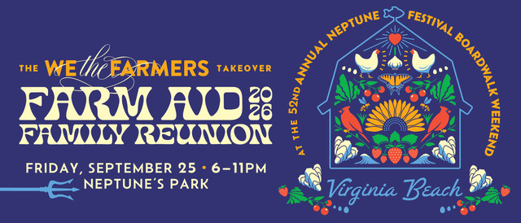
FOR IMMEDIATE RELEASE: September 25, 2026
MEDIA CONTACT: Camille Jewell; cjewell@vancomm.com; 202-248-5460

**MEDIA ADVISORY**
Farm Aid Family Reunion: “We the Farmers” Takeover Free Live Music Event Moved to The Bunker Brewpub, Sept. 25

VIRGINIA BEACH, Va. — Farm Aid Family Reunion: “We the Farmers” Takeover will proceed as scheduled Friday, Sept. 25, from 6 to 11 p.m. at The Bunker Brewpub, despite the cancellation of other programming during the 52nd Annual Virginia Beach Neptune Festival.

The free, pre-festival event will feature live music and stories, celebrating the rich musical traditions of Black, Indigenous and artists of color and the people and communities at the heart of family farm agriculture.

What: Farm Aid Family Reunion: “We the Farmers” Takeover at The Bunker Brewpub

When: Friday, Sept. 25 at 7 to 11 p.m. ET, doors open at 6:30 p.m. ET

Where: The Bunker Brewpub, 211 21st St, Virginia Beach, VA 23451

Who: Kyshona, Lette’s Line Dance, Rissi Palmer’s Revue featuring Rebecca Porter, Roberta Lea and The Smoke; and shirlette ammons. Hosted by “The Professor” Nick Harrison.

Interviews Available: Performing artists and representatives from Farm Aid will be available for interview beginning Friday afternoon. Media who would like to attend the event are encouraged to RSVP to Crystal Borde at cborde@vancomm.com.

This event is hosted by Farm Aid and presented in collaboration with Smithsonian Folklife Festival, along with the Virginia Tourism Corporation, Visit Virginia Beach, and the Virginia Department of Agriculture and Consumer Services. It is produced in partnership with the 52nd Annual Neptune Festival Boardwalk Weekend and Unmanageable Arts.

Attendees are encouraged to join the conversation on social media by using the hashtags #WeTheFarmers and #FarmAid2026. For festival updates, follow Farm Aid on Facebook (facebook.com/farmaid), Instagram (@FarmAid), X (@FarmAid), Bluesky (@farmaid.org) and Threads (@farmaid).

About Farm Aid
Farm Aid’s mission is to build a vibrant, family farm-centered system of agriculture in America. Farm Aid artists and board members Willie Nelson, Neil Young, John Mellencamp, Dave Matthews, Margo Price and Nathaniel Rateliff host an annual festival to raise funds to support Farm Aid’s work with family farmers and to inspire people to choose family farm food. Since 1985, Farm Aid, with the support of the artists who contribute their performances each year, has raised more than $90 million to support programs that help farmers thrive, expand the reach of the Good Food Movement, take action to change the dominant system of industrial agriculture and promote food from family farms.

About Neptune Festival
Founded in 1974, Virginia Beach Neptune Festival is a nonprofit organization producing more than 40 events each year. Neptune Festival’s mission is to celebrate the spirit of Virginia Beach through authentic experiences that foster joy, community and connection for all. Its signature event is an annual, three-day, family-friendly festival attracting more than 400,000 attendees, featuring live music, cultural programming, a 400+ vendor boardwalk activation, an international sand sculpting championship, and major civic events, generating $26.1 million in total economic impact for the City of Virginia Beach each year. The 52nd Annual Neptune Festival Boardwalk Weekend will take place Friday, Sept. 25 to Sunday, Sept. 27, 2026. For festival updates, follow Neptune Festival on Facebook (facebook.com/NeptuneFestival) and Instagram (instagram.com/NeptuneFestival), and visit www.neptunefestival.com.

###

