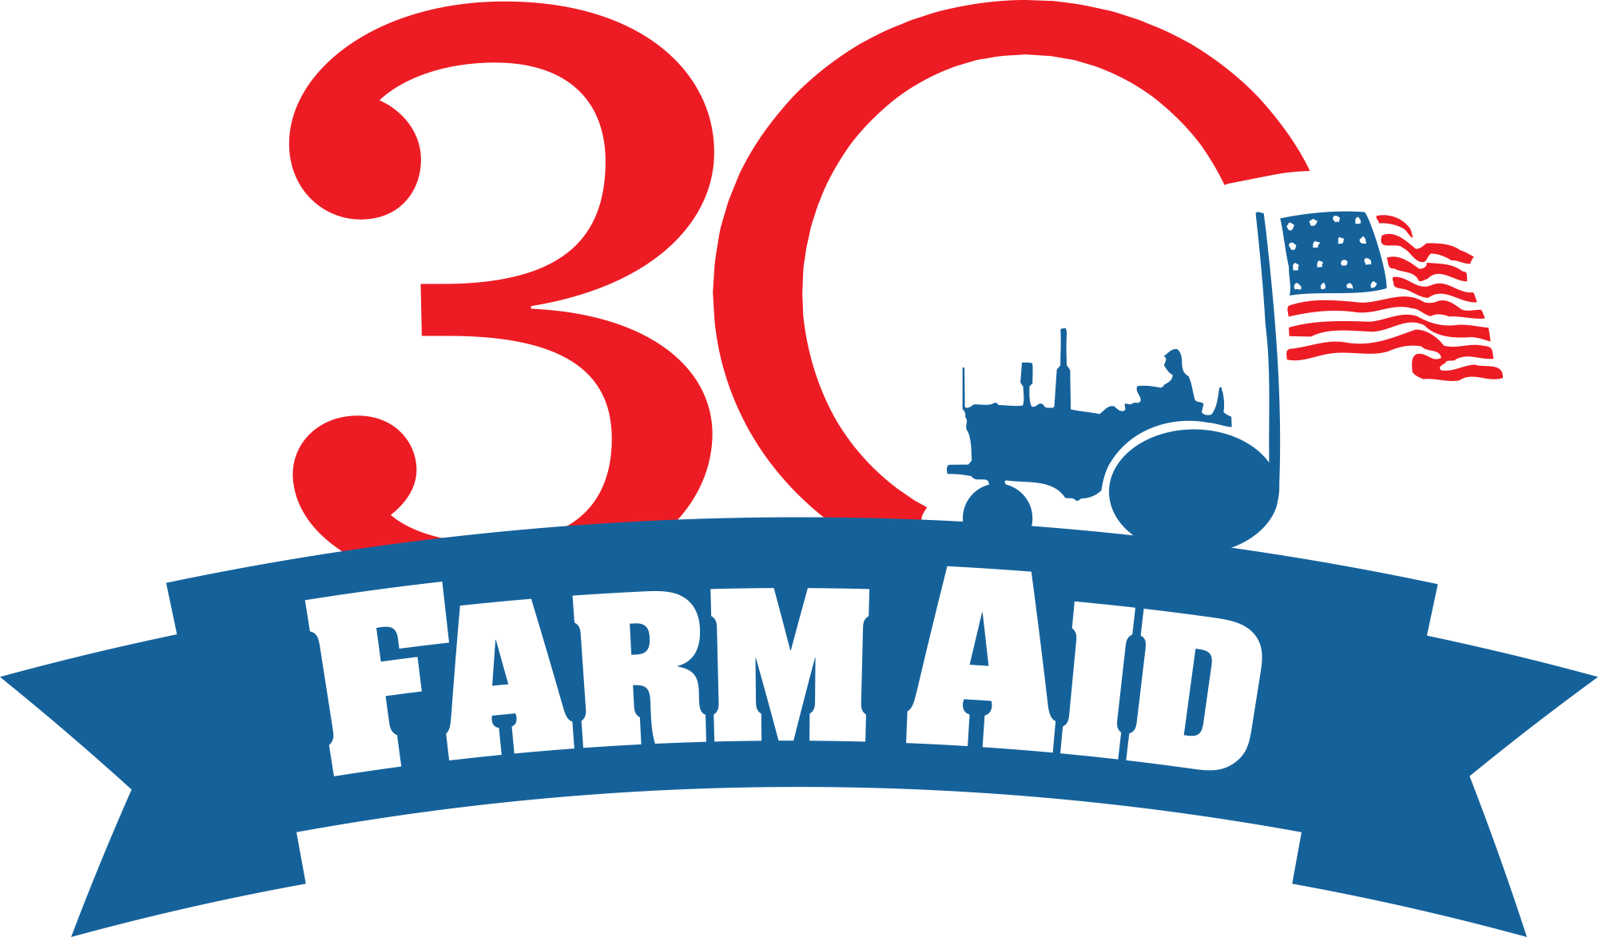

Farm Aid 30: Strength From Our Roots

September 17th & 18th, 2015
Fourth Presbyterian Church
126 E. Chestnut St, Chicago IL 60611

Farm Aid’s 30th anniversary is a milestone that celebrates more than America’s longest running concert for a cause; it marks an evolution in our shared work to advance family farm agriculture and to ground our food system in the values of justice, democracy, diversity and sustainability.

The moment that created Farm Aid – the 1980s Farm Crisis – is not an anomaly. Its lessons are as relevant as ever. Farm Aid 30: Strength From Our Roots will illuminate the greater context of the work we face in our food system today by engaging leaders involved with the early days of the Farm Crisis and the new generation of farm and food system builders. During this two-day meeting, participants will:

- Reflect upon what we’ve accomplished over 30 years to better understand this moment and better align our future work.
- Enjoy meaningful mentorship and networking opportunities between generations and across rural and urban communities.
- Identify the connections between the newer interest in good food from family farmers and the historic power struggles of our food and farm system.
- Identify key strategies for strengthening our capacity to achieve lasting change.

Day 1 of this gathering will explore how change is made through inspired storytelling and meaningful reflection from farm movement leaders and farm advocates who started their work in the midst of the 1980s farm crisis. In revisiting their stories, we will pull out important lessons about how to help farmers, build power and work together for lasting change.

Day 2 will bring intergenerational exchange, mentorship and strategic analysis between senior and emerging leaders through a series of working sessions.

AGENDA

Thursday, September 17th

1:30 pm Welcome Carolyn Mugar, Farm Aid

1:45 pm Our Shared History: Beginning Days of Farm Aid
What conditions sparked the first Farm Aid concert in the 80s? What did it mean for Willie Nelson, John Mellencamp and Neil Young to join family farmers in their struggle?
Moderator: Jim Hightower, Hightower Lowdown
Panel: Roger Allison, Missouri Rural Crisis Center
Carolyn Mugar, Farm Aid
Ralph Paige, Federation of Southern Cooperatives
Mark Ritchie, Former Minnesota Secretary of State
David Senter, American Agriculture Movement
Paul Sobocinski, Land Stewardship Project
Helen Waller, National Save the Family Farm Coalition

2:45 pm The Frontlines of the Farm Crisis: Farm Advocates
During the 80s farm crisis, a handful of farmers struggling to save their own farms started using their experience to help their neighbors fight back against foreclosure and abuse. The term “Farm Advocate” emerged to describe this frontline, farmer-to-farmer assistance. 30 years later, a small group of farm advocates are still at it, having saved thousands of farms during their careers.
Moderator: Charlie Thompson, Duke Institute for Documentary Studies
Panel: Mona Lee Brock, National Farm Crisis Center
Benny Bunting, Rural Advancement Foundation International – USA
Linda Hessman, Farm Advocate
Lou Anne Kling, Farmers’ Legal Action Group
Betty Puckett, Louisiana Interchurch Conference
Shirley Sherrod, Southwest Georgia Project
John Zippert, Federation of Southern Cooperatives

4:00 pm Coffee & Tea Break

4:30 pm Building our Power: the United Farmer & Rancher Congress
In September 1986, nearly 2,000 farmers and ranchers traveled to St. Louis, Missouri for the three-day United Farmer & Rancher Congress (UFRC). They represented rural America in crisis and came together to craft solutions. The Congress was a truly grassroots feat, gathering input from rural caucuses across the country to put forward policy solutions that would end the crisis and advance a brighter future. The progress made at the UFRC and via ensuing organizing work yielded major policy gains still critical for advancing family farm agriculture today.
Moderator: Jim Hightower, Hightower Lowdown
Panel: George Naylor, Iowa Citizens for Community Improvement
David Senter, American Agriculture Movement
Shirley Sherrod, Southwest Georgia Project
Pat Sweeney, Western Organization of Resource Councils
Mark Ritchie, Former Minnesota Secretary of State

5:30 pm Closing Address Scott Marlow, Rural Advancement Foundation – International

5:45 pm Social Hour

7:00 pm Film Screening of Country at McCormick Place (2301 S. Lake Shore Dr.)
Please join us for the final evening of our Film2FarmAid Festival! Country (1984) follows the trials and tribulations of a rural family as they struggle to keep their farm during the 1980s Farm Crisis. Refreshments will follow. Admission is $10 / $5 for farmers.

Friday, September 18th
8:00 am Breakfast Connect
Annual check-in to build community and share issue and campaign updates.

9:00 am Welcome

9:15 am Emerging Leaders Reflections
Emerging leaders from rural organizing, farmer support and good food organizations share their thoughts on how today’s work connects to the work of the past and how we can strengthen our collective capacity moving forward.
Moderator: Tim Gibbons, Missouri Rural Crisis Center
Panel: Sophie Ackoff, National Young Farmers Coalition
Amber Bell, Southwest Georgia Project
Katie Blanchard, Real Food Challenge
Jenny Rushlow, Conservation Law Foundation
Joe Schroeder, Rural Advancement Foundation International – USA
10:15 am Working Sessions for Mentorship & Capacity Building
Track 1: Moving Grassroots Power Building Forward
The United Farmer & Rancher Congress exemplified grassroots organizing and power building at its best. This session will break down what grassroots organizing looks like and provide clear models for making change. Seasoned and new activists alike will work together to apply tried and trued strategies to the challenges before us today.

Track 2: Fortifying the Work of Individual Farm Advocacy
This session will dig deeper into the underlying framework for individual farm advocacy and its connection with broader organizing and activism for social change. The track will provide an opportunity to outline the range of needs for a new generation of farm advocates in service of the expanding diversity of American family farms, as well as the financial, training and mentorship requirements to build and strengthen this critical network for change.

12:30 pm Lunch

1:30 pm Pick Your Own Breakout Discussions
Synthesizing these two tracks (grassroots power building & individual farm advocacy) around specific issues and concerns in family farm agriculture and food system work.

2:15 pm Reflections & Commitments
Sharing what we’re taking away from our gathering and what we’re giving back.

2:45 pm Closing

Farm Aid would like to thank our sponsors for their generous support of this important gathering.
